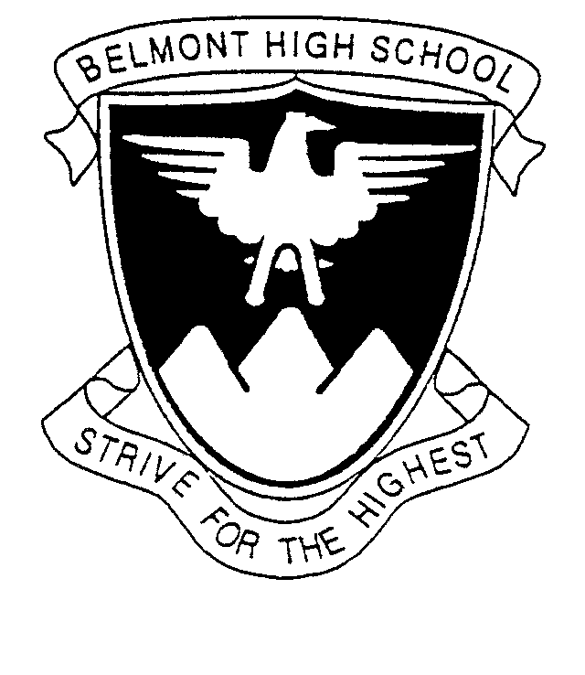

December 2018

STRIVE PROGRAM 2019

Dear Parents/Guardians

As part of the Year 9 Curriculum at Belmont High School, students are involved in an innovative program called Strive. This is an educational program designed to support the development of each student as a morally responsible person with a positive self-image, a sense of self-worth, who values others and respects their rights.

All students will be encouraged to develop recognition of the importance of acquiring and using the skills which will allow them to operate successfully as global citizens. A fundamental belief underpinning the program is that all students have the ability to learn and to progress – to strive into the future as positive individuals.
We aspire to support the development of all students as autonomous learners. Individual preferred learning styles are to be facilitated and extended by a wide range of effective teaching approaches and by the use of appropriate learning technologies.
The Strive program will provide a supportive, caring environment which promotes positive student and teacher relationships. It will continue to foster a positive attitude to learning and the pursuit of excellence in all students.
The program involves a range of activities, lessons and learning experiences for the students. Each term in 2019 will have a theme including challenges on a personal, academic, community and life skill level. Some of the important aspects of the Strive program embraced by students are community service work, regional excursions, guest motivational speakers and workshops, careers education and development of pathways and individual investigation tasks. Due to the cost of these educational activities a $100 levy applies.
If you have any further enquires about the program for 2019 please do not hesitate to contact me.

Naomi Serle
Strive Coordinator
serle.naomi.f@edumail.vic.gov.au

