Study VET Horticulture in 2023!
AHC20416 Certificate II Horticulture
(Delivery Site: Covenant College Trades Skills Centre, Creamery Road Bell Post Hill).
DO YOU …
- Love learning and working outside?
- Have a desire to work with plants, trees and other vegetation?
- Have an interest in landscaping and gardens?
- Think about gardening as a career after school?
- Want to learn from people who are already working in horticulture?
PATHWAYS
- Gardener
- Landscape designer
- Machinery operator
- Production horticulture
- Agronomist (soil scientist)
- Parks and gardens manager
- Nursery

COURSE OVERVIEW
Students will learn how to recognise a range of plants, how to successfully plant and propagate, perform garden maintenance and how to test and sample soils. Students will become familiar with operating a range of different machinery; including tractors. The course is designed to equip students with the basic skills and knowledge required to work within the horticulture industry. As part of their studies, students participate on regular trips to horticulture businesses around the Geelong region. This VET Horticulture course is made up of approximately 50% theory and 50% practical.

UNITS OF STUDY
- Recognise Plants
- Plant Horticulture Crops
- Undertake Plant Propagation
- Operating and Maintaining Machinery
- Treating Weeds and Plant Pests
- Soil Testing and Sampling
- Operating Tractors
- Applying Chemicals & Work Health & Safety

ENROLMENT
There are no prerequisites for VET Horticulture, applications are made to Covenant TSC through your home school VET Coordinator only. This course meets requirements for VCAL and VCE programs.
FURTHER INFORMATION home school or Covenant College TSC Coordinator Justin Boseley jboseley@covenant.vic.edu.au or Covenant College Office (03) 5278 5122.
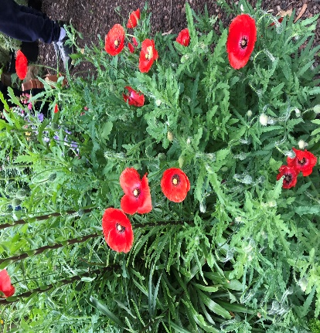
Unit Code | Title of Unit of Competency (UOC)
AHCWHS201 | Participate in work health and safety processes
AHCSOL202 | Assist with soil growing media sampling and testing
AHCWRK204 | Work effectively in the industry
AHCMOM202 | Operate tractors
AHCMOM204 | Undertake operational maintenance of machinery
AHCMOM203 | Operate basic machinery and equipment
AHCCHM201 | Apply chemicals under supervision
AHCPMG201 | Treat weeds
AHCPMG202 | Treat plant pests, diseases and disorders
AHCPCM204 | Recognise plants
AHCNSY207 | Undertake propagation activities
AHCPGD207 | Plant trees and shrubs
AHCNSY205 | Pot up plants
AHCPHT215 | Plant horticulture crops
AHCWRK209 | Participate in environmentally sustainable work practices

AHC20416 – Certificate II Horticulture
RTO: Access Skills Training (AST) TOID: 4603

UNIT DELIVERY SCHEDULE - (2023 & 2024)

Note: VCAA is conducting a review of the Cert II Horticulture in 2022.
*Course delivery details are subject to change
Queries regarding any fees payable for this course should be directed to the VET Coordinator at your home school.

