

SELECT ENTRY

ACCELERATED

LEARNING PROGRAM

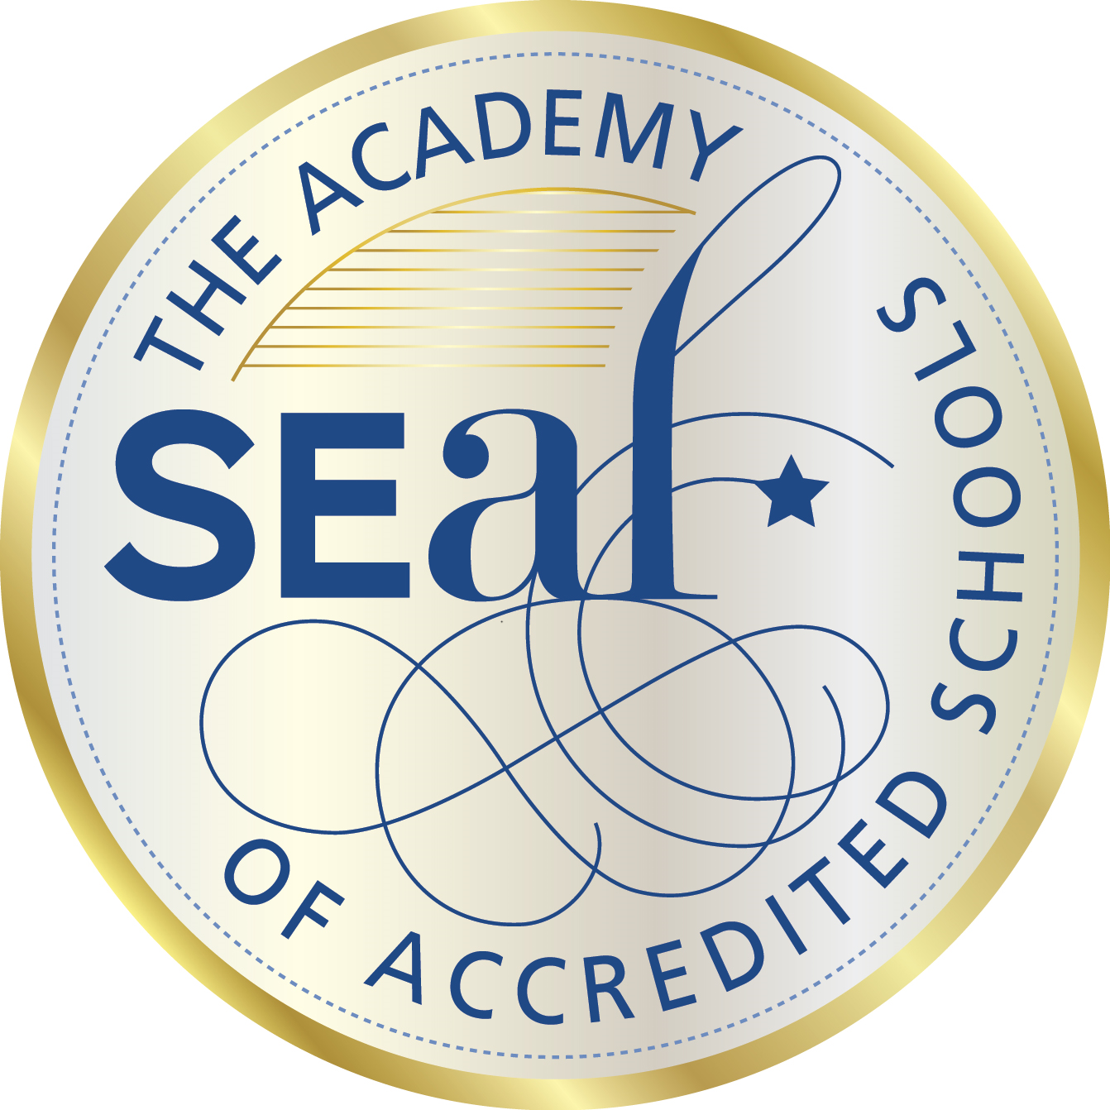 Year 7

BELMONT HIGH SCHOOL

2024

##### For further details, please contact the school on:

**Telephone:** (03) 5243 5355 and ask to speak to

Ms Lea Purdy or Ms Maddy Macreadie-Smith

**Facsimile:** (03) 5243 2420

**Email:** [leanne.purdy@education.vic.gov.au](mailto:leanne.purdy@education.vic.gov.au)

madeleine.macreadie-smith@education.vic.gov.au

***Disclaimer****:*

*Belmont High School must adhere to the Department of Education and Training (DET) Priority Order for Placement Policy for enrolment; this includes the SEALP class.*

|  |  |  |
| --- | --- | --- |
| CONTENTS | | |
|  |  |  |
|  |  | * Introduction * Select Entry Accelerated Program details * Study suitability for the program * Identification procedures * Course Overview 2024 – Years 7 – 9 * Options available after the third year |

|  |  |  |
| --- | --- | --- |
| SELECT ENTRY ACCELERATED LEARNING PROGRAM | | |
|  |  |  |
| Introduction |  | The Department of Education and Training recognises that all students should have a fulfilling and challenging education commensurate with their abilities in order to reach their full potential and remain engaged at school.  There are select entry programs offered in Government schools to provide appropriate schooling for academically gifted children.  **The Academy of Accredited SEAL Schools (TAASS)** is a collective of like-minded schools who strongly value Gifted Education in Victorian Government secondary schools. SEAL (Select Entry Accelerated Learning) schools offer engaging accelerated programs for their groups of gifted students. The SEAL program aims to address the learning needs of gifted and high potential students who are capable of working at a significantly faster pace and in greater depth than their age peers.  Learning in core subjects is accelerated for students in these programs, and opportunities for in-depth study are provided. Students usually complete Years 7-10 in three years, giving them an extended range of options for their final years of schooling.  Students are encouraged to complete additional VCE units, enabling them to accrue a greater breadth of subjects. Some students undertake VCE extension studies which allows them to complete one or more university subjects as part of their VCE. Some students choose to enter tertiary education after only five years of secondary schooling.  Secondary schools with SEAL programs are situated throughout metropolitan Melbourne and rural Victoria. Each school is responsible for determining its own selection criteria. Enquiries about Select Entry Accelerated Learning Programs should be made early in the year prior to the student’s year 7 placement. Entrance exams are usually held in Term 3.  Belmont High School is a registered provider of SEAL and first offered the program at Year 7 level in 2003. Matthew Flinders Girls Secondary College and Bellarine Secondary College also provide accredited SEAL programs in the Geelong / Bellarine region. |
|  |  |  |
| SELECT ENTRY ACCELERATED LEARNING PROGRAM | | |
|  |  |  |
| pe02310_pe01891_Select Entry Accelerated Program |  | At Belmont High School, students will complete an accelerated learning program within Years 7 to 9. At Year 10 they will begin some of their V.C.E. studies. Each year we will select a group of graduating primary students identified as being capable of work presented at a significantly higher level and faster pace than the majority of students with the same chronological age. This group will study their core subjects together for their first three years, after which a range of options will be available to individual students. The group will remain together as a house group for the length of time they are at school.  The aims of the program are:  ♦ to create a more challenging learning environment  ♦ to guarantee proficiency in the basic curriculum  ♦ to provide a program that meets the special needs of highly talented and motivated students   * To promote enrichment opportunities for highly talented students to reach their full potential.   Students will undertake a compacted curriculum in the following Learning Areas:  bd06193_  ♦ English  ♦ Mathematics  ♦ Science  ♦ Humanities  ♦ Languages – Indonesian or Italian   * Health   ***\*\* Please note the 2024 SEALP class will be studying INDONESIAN.***  Students complete the standard Years 7 to 9 courses in the other learning areas – Arts, Technology and Physical Education.  pe01085_ |
|  |  |  |

|  |  |  |
| --- | --- | --- |
| SELECT ENTRY ACCELERATED LEARNING PROGRAM | | |
|  |  |  |
| en00662_en00242_Student Suitability for the Program |  | Students who enter this course will need to:  ♦ be academically gifted – in approximately the top 10% of students their age  ♦ be motivated, interested and demonstrate a commitment to completing set tasks  ♦ be creative and demonstrate the ability to think fluently and/or flexibly  ♦ be prepared to involve themselves in a wide range of curricula and co-curricular offerings  ♦ have supportive parent(s)/guardian(s)  ♦ strongly recommended by their Primary school / Year 6 teacher.  The students will be expected to take part in all normal school activities. They will have access to, and be encouraged to participate in, all co-curricular programs such as sport, music, performing arts and student leadership.  Students should also expect to be involved, through their classroom activities, in extension and enrichment programs such as the English, Mathematics, Science and Humanities Competitions and other programs judged as providing suitable support for the work they are undertaking.  Students entering this course may not necessarily be currently achieving outstanding results.  pe02606_  pe02604_ |
|  |  |  |

|  |  |  |
| --- | --- | --- |
| SELECT ENTRY ACCELERATED LEARNING PROGRAM | | |
|  |  |  |
| Identification Procedures |  | Students wishing to join this program can be nominated by a parent or teacher.  The actual selection procedure will be overseen by a Select Entry Accelerated Learning Program Coordinators and include the following:  ♦ Academic Achievement test(s) – evaluating mathematical, problem solving, comprehension and creative writing abilities.   * NAPLAN results, if available, should be submitted with the Expression of Interest   ♦ primary teacher evaluation form  ♦ parent evaluation form  ♦ Interview – one with the student and another with parent(s) / guardian(s), if required.  The SEALP Coordinators will make the final decision on who will be offered entry to the program. Members of the selection team will not have any association with applicants.  A cost per student is involved for participation in the testing process ($ TBC).  Dates for testing for the 2024 Year 7 SEALP class are still to be confirmed  Students who enter the program after it has commenced will have completed similar identification procedures.  Students in the program will have ongoing evaluation of their progress against the stated objectives, and meetings of parents of students will be scheduled.  so00629_***The final decision on entry to, or exit from the program will always remain with the School in consultation with students and their parents/guardians, and relevant school staff.*** |
|  |  |  |

|  |  |  |  |  |  |
| --- | --- | --- | --- | --- | --- |
| SELECT ENTRY ACCELERATED LEARNING PROGRAM | | | | | |
|  |  |  | | | |
| CourseOverview2024Years 7 – 9 |  | **Year 7 Select Entry Accelerated Learning Program (SEALP)** | **Periods/**  **Fortnight** | **Year 8 Select Entry Accelerated Learning Program (SEALP)** | **Periods/**  **Fortnight** |
|  |  | English | 9 | English | 9 |
|  |  | Humanities | 6 | Humanities | 6 |
|  |  | Science | 9 | Science | 7 |
|  |  | Mathematics | 9 | Mathematics | 9 |
|  |  | Physical Education | 6 | Physical Education | 6 |
|  |  | Health | 3 | Health | 3 |
|  |  | Language (Indonesian) | 6 | Language (Indonesian) | 6 |
|  |  |  |  |  |  |
|  |  | Art |  | Art |  |
|  |  | Visual Communication |  | Visual Communication |  |
|  |  | Food Technology |  | Food Technology |  |
|  |  | Materials Technology | 3x4 | Materials Technology | 3x4 |
|  |  | Fibre Technology |  | Fibre Technology |  |
|  |  | Systems Technology |  | Systems Technology |  |
|  |  | Drama |  | Drama |  |
|  |  | Ceramics |  | Ceramics |  |
|  |  | Music  Digital Technology |  | Music  Digital Technology |  |

|  |  |
| --- | --- |
| **Year 9 Accelerated Learning Program (SEALP)** | **Periods/**  **Fortnight** |
| English | 9 |
| Science | 9 |
| ‘Humanities’ | 7 |
| Maths (Year 10) – Methods or General | 9 |
| Physical Education & Health | 5 |
| Language (Indonesian)  SEALP Strive | 6  6 |
| Plus,  choice from Year 10 Electives,  and VCE (depending on subject selections) | |
|
|
|
|

|  |  |  |
| --- | --- | --- |
| SELECT ENTRY ACCELERATED LEARNING PROGRAM | | |
|  |  |  |
| Options Available after the Third Year |  | Belmont High School understands the importance of managed individual pathways. This planning will be a co-operative activity involving parents/guardians, program co-ordinators, career counsellors and the student.  Finishing school earlier than most other students may present some challenges, however through experience, we know that the challenges are few, and do not outweigh the benefits of an accelerated program. We therefore present a range of options that, following counselling, may available to students on completion of Year 3:  ♦ complete a normal Year 10 program (elective)  ♦ mix Year 10 with VCE studies and take 3 years to complete school.  ♦ mix Year 10 with VCE studies, take 3 years to complete school and include VET studies  ♦ mix Year 10 with VCE studies, take 3 years to complete school and include some university enhancement studies  ♦ complete VCE in 2 years and work for a year (before entering tertiary studies)  ♦ complete VCE in 2 years and progress directly to tertiary studies.  **Please note: Belmont High School provides all students with ongoing course and career advice. Pathways within the program will be determined by MERIT (performance, teacher recommendations and the demands of the student’s subject program).**  bs00967_ |