CUA30920 CERTIFICATE III IN MUSIC
(PERFORMANCE)

Course Overview
This qualification reflects the role of individuals who apply a broad range of competencies in a varied work context in the music industry, using some discretion and judgement and theoretical knowledge. They may provide support to a team.
This program is a performance program and includes areas of study in which students must learn an instrument and perform on that instrument with others and by themselves.

AIMS
The aim of this course is to provide participants with the knowledge and skills to achieve competencies that will enhance employment prospects in the Music Industry.
The course enables participants to gain a recognized credential and to make a more informed choice of vocation or career path.

ENROLMENT
Students are required to undertake a successful audition prior to enrolment in first year. Students enrolling in the second year of the Certificate III in Music are required to have successfully completed the first year.

PATHWAYS
This program has pathways into Certificate IV in Music, University and TAFE courses in Music and Audio Engineering.

Duration
The Certificate III in Music is completed over two years. Classes run from 1:30 – 5:30pm on Wednesday for 1st year and Monday for 2nd year.

Students interested in the Music Industries are invited to apply.
Contact
Belmont high School
Rotherham Street, Belmont 3216
Tel: 03 5243 5355

Megan McPherson
VET Coordinator Belmont High School
Megan.mcpherson@education.vic.gov.au
Rosemary Humphrey- VET Trainer
rosemary.humphrey@education.vic.gov.au

Units 1 and 2 Core and Electives
CUACMP311 Implement copyright arrangements
CUAIND313 Work effectively in the music industry
CUAIND314 Plan a career in the creative arts industry
CUAMCP312 Write song lyrics
CUAMPF213 Perform simple repertoire in ensembles
CUAMCP313 Create simple musical pieces using music technology

Units 3 and 4 Core and Electives
CUAMPF311 Develop technical skills for musical performances
CUAMPF312 Prepare for musical performances
CUAMPF315 Develop and perform musical improvisation
CUAMPF412 Develop and apply stagecraft skills
CUAMPF414 Perform music as part of a group
OR CUAMPF416 Perform music as a soloist

VCE or VCAL Credits
Participants will be eligible for credits of up to four VCE units, two units at Units 1 and 2 and two units at Units 3 and 4 level. VET Music has a scored assessment which means a study score is available which can contribute directly to your ATAR. Completion of all or part of the Certificate will contribute to your Vocational Major Certificate.
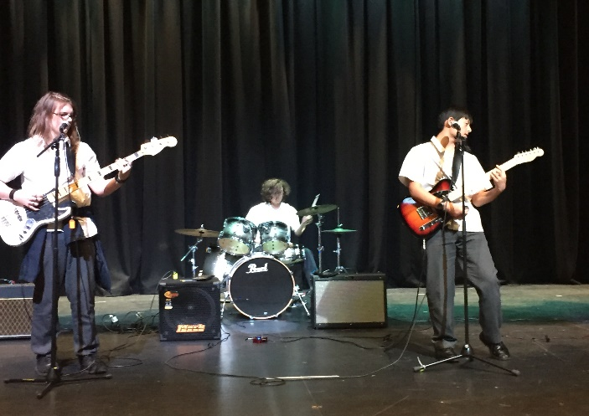

Possible Career Pathways:
- Assistant Music Manager
- Instrumental Music Teacher
- Band Member
- Singer/ song writer

