**RTO Toid 40548**

**SIS20419 CERTIFICATE II IN OUTDOOR RECREATION**

**Course Overview**

This program will provide the students with specific skills and knowledge to achieve competencies that will enhance employment prospects in the Outdoor Recreation industry.

**Aims**

Outdoor Recreation provides students with opportunities to explore a variety of outdoor recreation activities while developing fundamental skills such as communication, resilience, team work. The fundamental competencies that students are required to perform form a terrific foundation for a life in the outdoors.

**Duration**

The duration of this course is one year. Classes will be run on a Wednesday afternoon from 1:30 – 4:30pm

**Enrolment**

Students must have an interest in the outdoors, enjoy activities such as surfing and hiking and be willing to attend overnight camps. This is a hands- on course with both theoretical and practical assessments.

**Pathways**

Students must successfully complete this course in order to progress to Certificate III in Sport and Recreation (Partial Completion).

This course is 50% theory and 50% practical

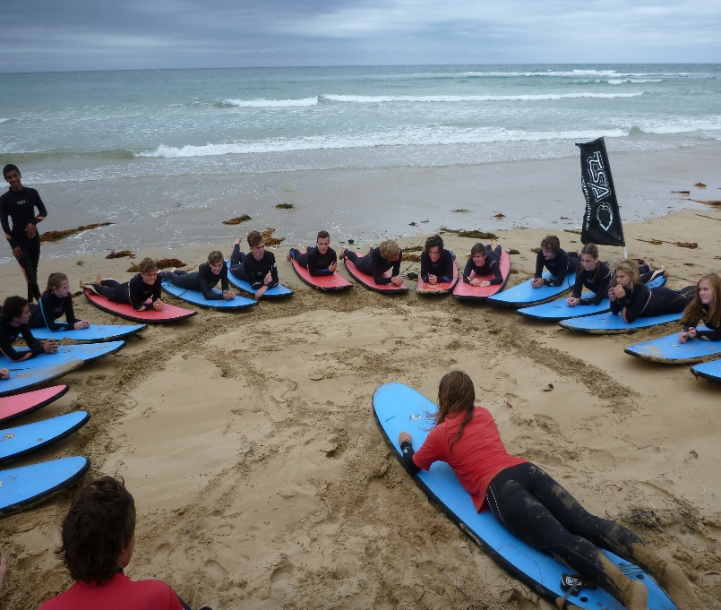

Students interested in the Sport and Recreation Industries are invited to apply.

**Contact**

Belmont high School

Rotherham Street, Belmont 3216

Tel: 03 5243 5355

Megan McPherson

VET Coordinator Belmont High School

[Megan.mcpherson@education.vic.gov.au](mailto:Megan.mcpherson@education.vic.gov.au)

Thomas Bell and Scott Mackenzie- VET Outdoor Recreation Trainers

[thomas.bell@education.vic.gov.au](mailto:thomas.bell@education.vic.gov.au)

scott.mackenzie@education.vic.gov.au

**Course Content**

**Units 1 and 2 Core**

HLTWHS001 Participate in workplace health and safety

SISOFLD001 Assist in conducting outdoor recreation sessions

SISOFLD002 Minimise environmental impact

SISXIND002 maintain sport, fitness and recreation industry knowledge

**Electives**

SISOBWG001 Bushwalk in tracked environments

SISOFLD006 Navigate in tracked environments

SISAQU002 Perform basic water rescues

SISOSRF001 Surf small waves using basic manoeuvres

HLTAID011 Provide First Aid

SISXFAC001 Maintain equipment for activities

SISXEMR001 Respond to emergency situations

**Contribution to VCE**

Students undertaking this certificates are eligible for up to two VCE VET units on their VCE or VCE- VM statement of results at a Unit 1 and 2 level.

Students demonstrate their knowledge and skills of the core units of competency through participating in a range of outdoor activities including:

* Surfing
* Hiking
* Water rescues
* Surf camp (3 days, 2 nights)
* Hike Camp (2 days, 1 night)

*Possible Career Pathways:*

* *Outdoor Recreation assistant*
* *School camp activity assistant*
* *Water sports activities assistant*
* *Outdoors supplier retail assistant*