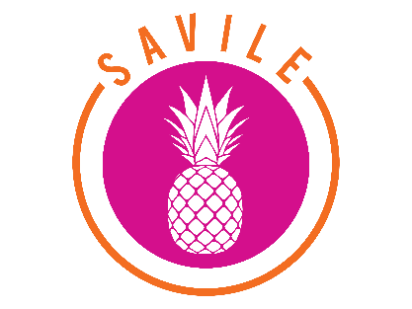

SIS30122 CERTIFICATE III IN SPORT, AQUATICS RTO Toid 45452
AND RECREATION (Partial Completion)

Course Overview
This qualification reflects the multi-skilled role of individuals in operational and customer support positions in the sport or community recreation industry. These individuals are competent in a range of activities and functions requiring autonomous work within a defined range of situations and environments.

They work in locations such as fitness centers, sporting grounds or complexes, leisure and aquatic centres and community recreation centres.

AIMS
The aim of this course is to provide participants with the knowledge and skills to achieve competencies that will enhance employment prospects in the Sport and Recreation Industry.
The course enables participants to gain a recognized credential and to make a more informed choice of vocation or career path.

Duration
This course will run for one year and students will receive a statement of attainment at the end of the year. It is run on a Monday afternoon from 1:30pm.

ENROLMENT
Students are required to successfully complete SIS20419 Certificate II in Outdoor Recreation or equivalent units.

Pathways
The course provides pathways into further qualifications in Sport and Recreation, TAFE, University, Outdoor Recreation, Fitness, Sport and Coaching courses. It is suitable for an Australian Apprenticeship pathway.

This course is 60% Theory, 40% Practical

Students interested in the Sport and Recreation Industries are invited to apply.
Contact
Belmont high School
Rotherham Street, Belmont 3216
Tel: 03 5243 5355

Megan McPherson
VET Coordinator Belmont High School
Megan.mcpherson@education.vic.gov.au
Nicholas Masters VET Sport and Recreation Trainer
nicholas.masters@education.vic.gov.au

Course Content

Units 3 and 4 Core and Electives
BSBWHS303 Participate in WHS hazard identification, risk management and risk control
SISXCAI004 Plan and conduct programs

SISXCAI006 Facilitate Groups
SISXRES002 Educate user groups
SISSCO001 Conduct sport coaching with foundation level participants

VCE OR VCE- VM Credits
Students undertake a Scored Assessment contributing towards their ATAR score.
Students undertaking this certificate are eligible for two VCE VET units towards their VCE or Vocational Major statement of results as a VCE VET Units 3 and 4 sequence.
As only one year of this course is completed students will achieve a statement of attainment for the units they successfully complete.

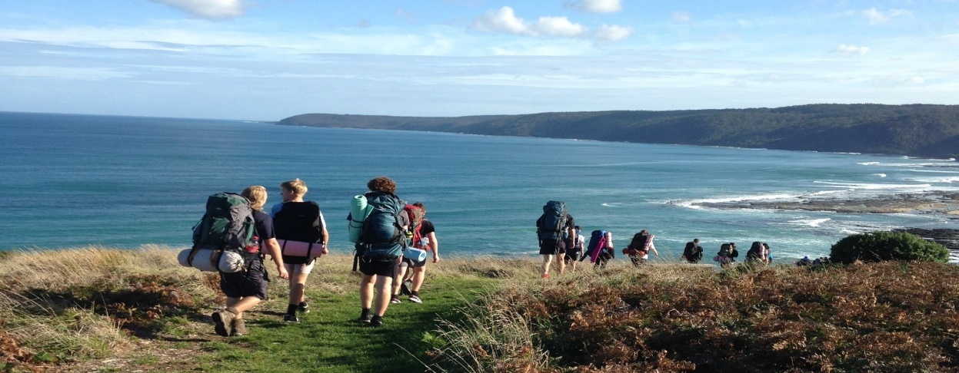

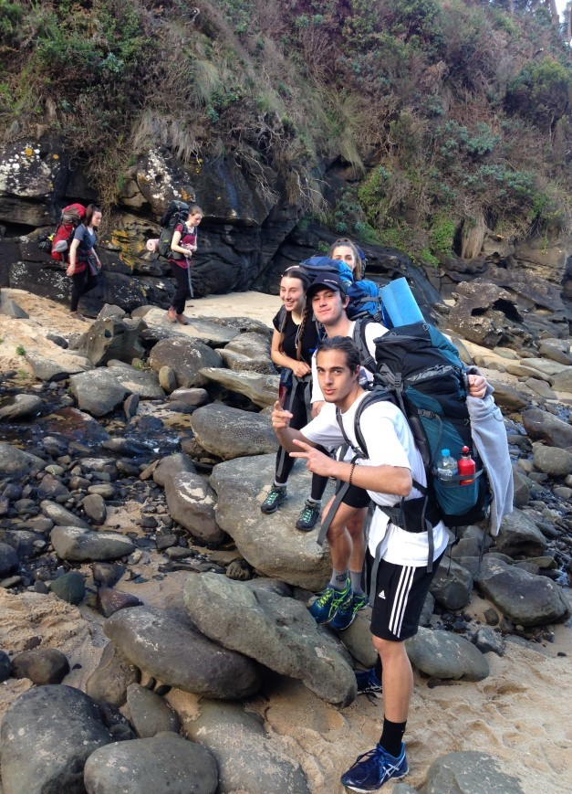
Students demonstrate their knowledge and skills of the core units of competency through participating in a range of outdoor activities including:
- Snorkelling
- Stand up Paddleboarding
- Mountain Biking
- Hike camp (3 days, 2 nights)
- Canoe camp (3 days, 2 night)

Possible Career Pathways:
- Recreation Officer
- Sport and Recreation Administration Officer
- Leisure Services Officer

Great Ocean Walk

